LSDP Virtual Lab, 26th September

**Shreyansh Saha**

**17BCE1148**

## Code:

package lsdpLab;

import java.io.IOException;

import org.apache.hadoop.fs.Path;

import org.apache.hadoop.conf.*;

import org.apache.hadoop.io.*;

import org.apache.hadoop.mapreduce.*;

import org.apache.hadoop.mapreduce.lib.input.*;

import org.apache.hadoop.mapreduce.lib.output.*;

public class VirtualLab {

public enum ct {

cnt, nt

};

public static class Map extends Mapper<LongWritable, Text, Text, IntWritable> {

public void map(LongWritable key, Text value, Context context) throws IOException, InterruptedException {

String line = value.toString();

String[] str = line.split(",");

int g1 = Integer.parseInt(str[7]);

float avg = 0;

for (int i = 7; i < 10; i++)

avg += Integer.parseInt(str[i]);

avg /= 4;

if (g1 < 10) {

context.getCounter(ct.cnt).increment(1);

context.write(new Text(str[0] + " " + g1), null);

}

if (avg > 13) {

context.getCounter(ct.nt).increment(1);

}

}

}

public static void main(String[] args) throws Exception {

Configuration conf = new Configuration();

Job job = new Job(conf, "VirtualLab");

job.setJarByClass(VirtualLab.class);

job.setOutputKeyClass(Text.class);

job.setOutputValueClass(IntWritable.class);

job.setMapperClass(Map.class);

job.setInputFormatClass(TextInputFormat.class);

job.setOutputFormatClass(TextOutputFormat.class);

FileInputFormat.addInputPath(job, new Path(args[0]));

FileOutputFormat.setOutputPath(job, new Path(args[1]));

job.setNumReduceTasks(0);

job.waitForCompletion(true);

Counters cn = job.getCounters();

cn.findCounter(ct.cnt).getValue();

cn.findCounter(ct.nt).getValue();

}

}

## Output:

#### Output for Counter



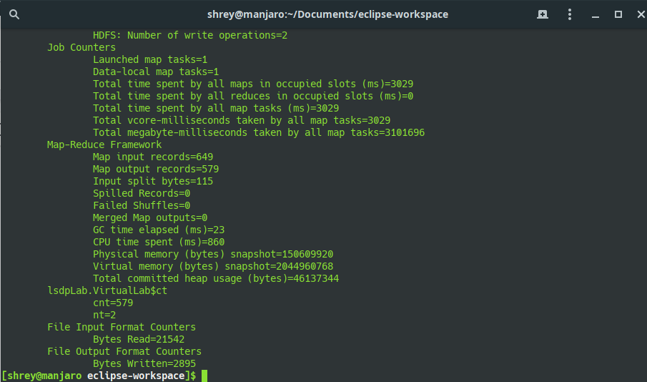

#### Output file with School Detail and GD1

